# Machine Learning on Arduino:

Approach: People have developed algorithm and successfully deployed them on Arduino board. We also can approach the same, by training the data on computer and save the weights then upload it directly into Arduino to predict the output. These prediction problem can easily solve using multivariable analysis, K-nearest neighbor or deep learning.

Let’s assume a multivariate model,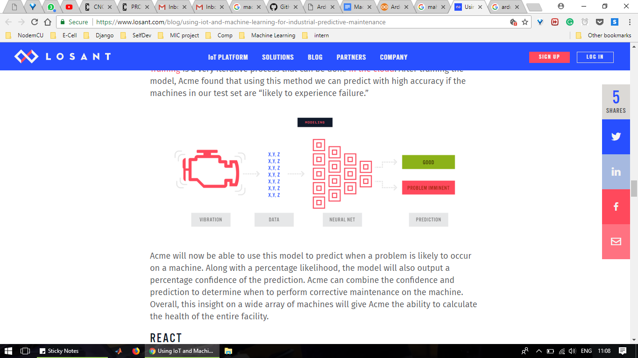

Y= a+bX+cX^2+...

The weights a, b, c, etc. will be obtain using training on computer.  
Arduino uses 32 bits to represent float values. Hence in 500KB Arduino Due, we can store 16000 integers. Hence storing a machine learning model is easily possible.

(Note: considering Arduino has only ML model)

Hardware Choice:

Be aware that the sample network with 7 inputs, 8 hidden neurons, and 4 outputs(i.e. 88 weights) is about as large as you'll be able to run on the Arduino Uno's 2K SRAM.

In our case with a good prediction, Arduino Due is seems a good choice as cost is around Rs.1500 with flash memory is of 480 KB and 96 KB SRAM which is better than Arduino Mega which is available at the Rs.1000 with 256KB flash memory and 8KB SROM.

References:

1)Resource-efficient Machine Learning in 2 KB RAM for the Internet of Things

<http://proceedings.mlr.press/v70/kumar17a/kumar17a.pdf>

2) Arduino Due

<https://store.arduino.cc/usa/arduino-due>

3) Arduino Mega

<https://store.arduino.cc/usa/arduino-mega-2560-rev3>

4)Simple ML model in Arduino

<http://robotics.hobbizine.com/arduinoann.html>

# BugZilla:

Bugzilla is defect-tracking systems allow teams of developers to keep track of outstanding bugs, problems, issues, enhancement and other change requests in their products effectively. Bugzilla is absolutely free in price.

We can use it at our labs to update our software’s bugs for operator and a new developer who’ll be working on it. We have CNC machine software and robotic arm software. Our team can also use it for updating design issues and Arduino code issues of every project, it’ll make things well organize and save a lots of time later.

Steps:

1. Download and install
2. Create account and Sign in
3. Go into administration and Create a new product so that others could report bug about it.
4. Go to home and post a bug by selecting our products.

Reference:

1)How to register a product:

<https://www.bugzilla.org/docs/4.2/en/html/products.html>

2)How to report a bug:

<https://www.bugzilla.org/docs/4.2/en/html/bugreports.html>

3)How to search for a bug:

<https://www.bugzilla.org/docs/4.2/en/html/query.html>

# WebRTC:

WebRTC is a free, open project that provides browsers and mobile applications with Real-Time Communications (RTC) capabilities via simple APIs. WebRTC is absolutely free in price and open source.

We can use its website integration here in couple of ways:

In House use:

1. Employees can share files easily through their login on website storing it in backend.
2. They can have meetings on conference call through their logins.

Used by Customers:

1. Customers can have video appointments for furniture demos on our website.

Deploying WebRTC on orangewoodlabs.com will keep us more organize and will build a strong customer relation.

How to deploy:

1)API for real time communication between browsers

<http://w3c.github.io/webrtc-pc/>

2)API for media streaming

<https://w3c.github.io/webrtc-pc/>